**RABAKS SUPERSTORE SALES ANALYSIS REPORT Q1 2019**

1. Introduction

Objective of the Project:  
The primary goal of this analysis is to assess the sales performance of Rabaks Superstore for the first quarter of 2019. This involves identifying peak sales periods, top-performing product lines, preferred customer segments, and popular payment methods in order to derive actionable insights for improving business outcomes.

Problem Being Addressed:  
This dataset explains when, where, and how customers are shopping to optimize marketing strategies, stock management, and customer engagement. The store also wants to evaluate which customer segments and branches are contributing the most to total sales.  
Key Datasets and Methodologies:  
The analysis leverages sales data represented in an Excel-based dashboard. Tools used include Pivot Tables, charts, and conditional formatting to visualize trends in time, customer type, product line performance, and payment behavior.  
**2. Story of Data**

**Data Source:**  
The data appears to be sales records dataset and captures customer transactions over January to March 2019 and it was downloaded from Kaggle.

**Data Structure:**  
Each transaction includes variables such as date and time, product line, branch, gender, quantity, ratings, customer type, payment type, and revenue.

**Important Features:**

* **Sales Revenue:** Central to performance assessment.
* **Product Line & Branch:** Useful in evaluating inventory and regional performance.
* **Customer Type (Member/Normal):** Indicates customer loyalty dynamics.
* **Payment Type:** Helps understand transaction preferences.
* **Weekly sales trend:** Aggregates total sales values by each calendar week
* **Peak shopping hour:** It tracks sales volume across different hours

**Data Limitations or Biases:**

* The data covers only one quarter.

**3. Data Splitting and Preprocessing**  
Data Cleaning**:** The data is already cleaned. Missing earnings or job durations were excluded.  
Handling missing values:No indication of missing values in the visual summary, suggesting clean data or omission of null rows.

Data Splitting:

* Dependent Variable: Total, rating, Tax and quantity
* Independent Variables: Branch, Product Line, Payment Type, Customer Type, Time, Invoice ID, gender, Date, and city

Industry Context:  
A grocery store with fast-moving consumer goods

Stakeholders: Sales and Marketing Teams, Branch Managers, Inventory and Finance Departments, Business Strategy Executives and Chief executive officer.

Value to the Industry:  
Improving promotional targeting, inventory distribution, and customer retention and revenue generation.

Important Features:

* Sales Revenue: Central to performance assessment.
* Product Line & Branch: Useful in evaluating inventory and regional performance.
* Customer Type (Member/Normal): Indicates customer loyalty dynamics.
* Payment Type: Helps understand transaction preferences.
* Peak shopping hour: It tracks sales volume across different hours

Data Limitations or Biases:

* The data covers only one quarter.

4. Pre-Analysis

Identify Key Trends:

* Peak Shopping Hour: 7 PM is the highest-grossing hour.
* Best Week for Sales: 4th week of the quarter.

Potential Correlations:

* Members appear to spend more than normal customers.
* Branch C has a consistent lead in sales performance.
* Cash is the most preferred mode of payment.

Initial Insights:

* Food and beverages consistently perform best across both sales and ratings.
* High evening sales suggest post-work hour shopping behavior.

5. In-Analysis

Unconfirmed Insights:

* Branch C may have longer operating hours or better inventory, explaining higher sales.
* Fashion accessories are highly rated but are not top sellers implies potential under marketing or overpricing.

Recommendations:

* Explore why high rated products like fashion accessories aren't translating into higher sales.
* Consider incentivizing eWallet use to promote digital transactions.

Analysis Techniques Used in Excel:

* Pivot Tables for aggregation by category (e.g., branch, product line).
* Line and bar charts for trends and comparisons.
* Pie charts for distribution analysis.

6. Post-Analysis and Insights

Key Findings:

* Total Sales: $322,970
* Top Product Line: Food and Beverages ($56,144)
* Best Customer Type: Members ($164,223)
* Preferred Payment: Cash ($112,206)
* Top Branch: Branch C ($110,568)

Comparison with Initial Findings:

* The assumption that members are more valuable is confirmed.
* Despite higher ratings, some products underperform in sales.

Included Charts:

* Line Chart: Weekly sales and hourly sales trends.
* Bar Charts: Product line performance, ratings, and payment preferences.
* Pie Charts: Best branch and customer type distribution.

7. Data Visualization and charts

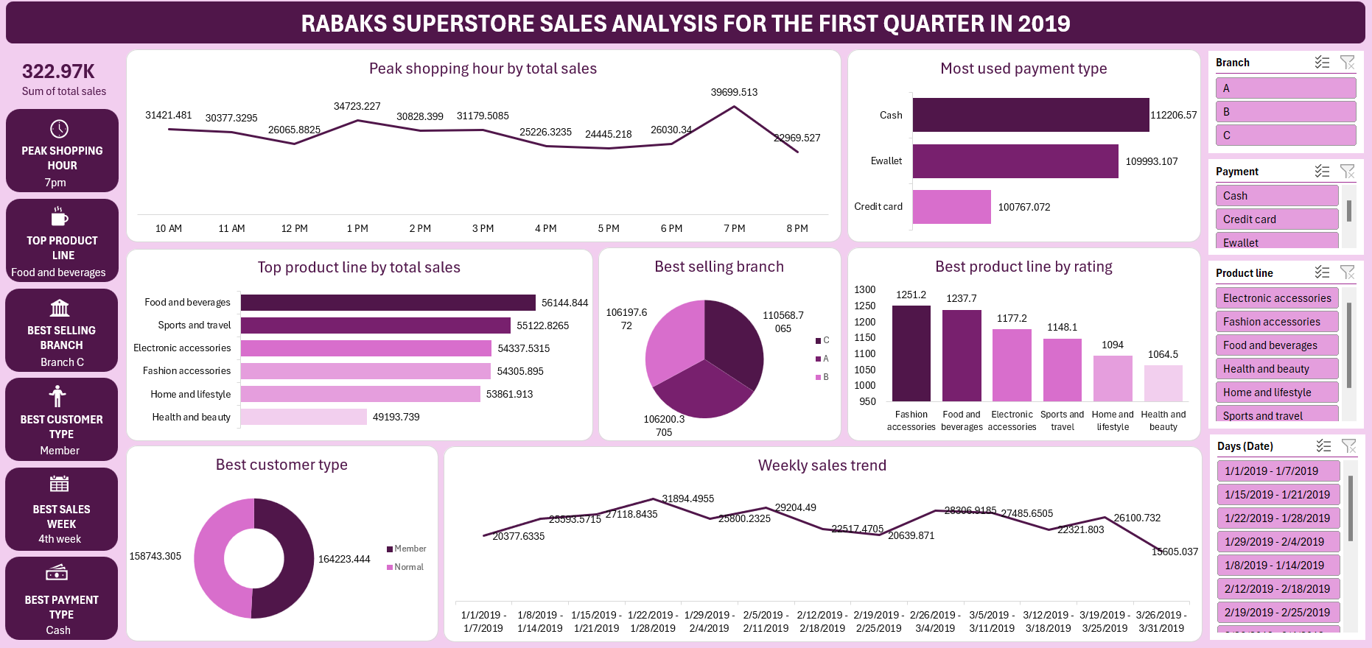

Explanation of Visuals:

* Weekly Sales Trend: Reveals fluctuations with a peak in week 4.
* Top Product Line Chart: Food and beverages lead significantly, suggesting strong consumer demand.
* Payment Method Chart: Indicates a need for more diversified payment incentives.

8. Recommendations and Observations

Actionable Insights:

* Focus marketing efforts around 7 PM when customer activity peaks.
* Consider loyalty programs or exclusive perks for Member customers.
* Allocate more stock and promotions to Branch C based on its performance.

Optimizations:

* Improve awareness or placement of high-rated but low-selling products.
* Encourage credit card and eWallet usage through discounts to modernize transactions.

Unexpected Outcomes:

* Despite being well-rated, Health and Beauty products lag in sales—warrants product review or repositioning.

9. Conclusion

Key Learnings:

* Time, branch, and customer type play pivotal roles in driving sales.
* Ratings don’t always correlate with sales performance implying gaps in marketing or pricing strategies.

Limitations:

* One-quarter data is insufficient for long-term trend forecasting.

Future Research:

* Incorporate customer demographics and seasonal factors.
* Extend analysis to additional quarters for trend consistency.

10. References & Appendices

* Dataset: Sales performance analysis Dataset (Kaggle)
* Tool: Microsoft Excel